REPORT GAME

Name: Bui Ngoc Thanh Mai

Student ID: 1551021

1. Game introduction

This game story is begin with a litle girl name Lily, she has lived under the protection of her parent from the childhood. She has a safe and sound life which everyone ever dream of. However, she is not happy with her life since she does not have freedom to explore the world in the way she want. Everything is going on as it alway be until Lily’s 16th birthday. No one can find her. She is disaspear without a letter or a word. The story behind the missing of this little girl is start with a voice from behind the tree. There is a men voice tell her to go with him behind the tree, he will take her travel the world. Lily do as he said and in the second, she is lost in a whole new world where many kind of monsters try to take away her soul. Will she escape it?

1. Features

The main character mission is passing through all the monsters in the forest without running out of soul and health. She can go left and right and can jump over the head of monsters.

Main character profile:

Soul: 200

Mana: 100

Can jump

Can run

This game has 2 level:

* Light forest
* Dark forest

The main character will try to run to the bottom right of the screen where has the door to next level or way out of the forest.

In their way to escape the forest, she can met many monsters:

**Red Mushroom:** Damage to soul = 10. Damage to mana = 20

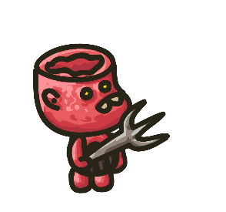

**Orange Fox:** Damage to soul = 50. Damage to mana = 0

**/Users/maibui/Documents/Game/Game-A03/2DPlatformerController/Assets/Sunnyland/artwork/Sprites/player/idle/player-idle-1.png**

She can also collect item that boost her health:

**Berry**: Boost soul = 20

/Users/maibui/Documents/Game/Game-A03/2DPlatformerController/Assets/Sprites/Apicot_Berry.png

**Water**: Boost mana = 50

/Users/maibui/Documents/Game/Game-A03/2DPlatformerController/Assets/Sprites/Fresh_Water_Sprite.png

She can also collect coin to earn mark:



1. Resources reference

<https://assetstore.unity.com/packages/2d/characters/sunny-land-103349>

<https://craftpix.net/freebies/free-monster-enemy-game-sprites/>